P 5 Configuring BGP with Default Routing
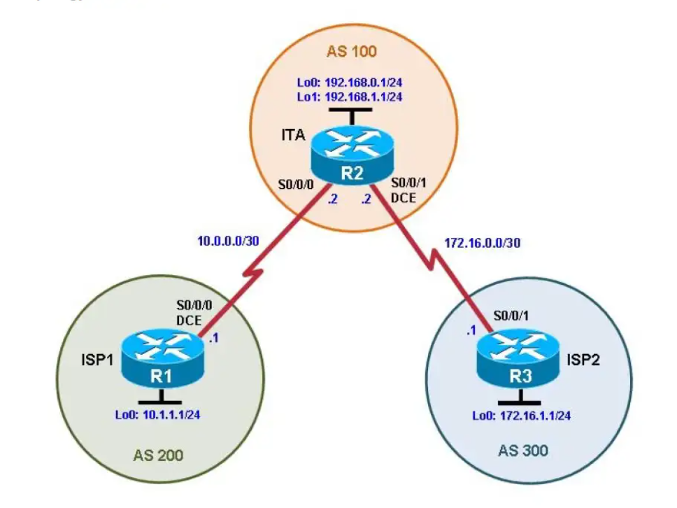

Background
The International Travel Agency (ITA) relies extensively on the Internet for sales. For this reason, the ITA has
decided to create a multihomed ISP connectivity solution and contracted with two ISPs for Internet
connectivity with fault tolerance. Because the ITA is connecting to two different service providers, you must
configure BGP, which runs between the ITA boundary router and the two ISP routers.

Objectives
• Configure BGP to exchange routing information with two ISPs.

Step 1: Configure the hostname and interface addresses.

Router R1 (hostname ISP1) hostname ISP1
interface Lo0
description ISP1 Internet Network
ip address 10.1.1.1 255.255.255.0
interface Serial0/0/0
description ISP1 -> ITA
ip address 10.0.0.1 255.255.255.252
clock rate 128000
no shutdown
end

Router R2 (hostname ITA)
hostname ITA
interface Lo0
description Core router network link 1
ip address 192.168.0.1 255.255.255.0 !

interface Lo1
description Core router network link 2
ip address 192.168.1.1 255.255.255.0
interface Serial0/0/0
description ITA -> ISP1
ip address 10.0.0.2 255.255.255.252
no shutdown

interface Serial0/0/1
description ITA -> ISP2
ip address 172.16.0.2 255.255.255.252
clock rate 128000
no shutdown
end

Router R3 (hostname ISP2)
hostname ISP2
interface Lo0
description ISP2 Internet Network
ip address 172.16.1.1 255.255.255.0

interface Serial0/0/1
description ISP2 -> ITA
ip address 172.16.0.1 255.255.255.252
no shutdown
end

Step 2: Configure BGP on the ISP routers.

ISP1(config)# router bgp 200
ISP1(config-router)# neighbor 10.0.0.2 remote-as 100
ISP1(config-router)# network 10.1.1.0 mask 255.255.255.0

ISP2(config)# router bgp 300
ISP2(config-router)# neighbor 172.16.0.2 remote-as 100
ISP2(config-router)# network 172.16.1.0 mask 255.255.255.0

Step 3: Configure BGP on the ITA boundary router.

ITA(config)# router bgp 100
ITA(config-router)# neighbor 10.0.0.1 remote-as 200
ITA(config-router)# neighbor 172.16.0.1 remote-as 300
ITA(config-router)# network 192.168.0.0
ITA(config-router)# network 192.168.1.0

ITA# show ip route

Step 4: Verify BGP on the routers.

ITA# show ip bgp
ISP1# show ip bgp
ITA# show ip bgp neighbors

Step 5: Configure route filters.

ISP2# show ip rout

ITA(config)# access-list 1 permit 192.168.0.0 0.0.1.255
ITA# clear ip bgp *

ISP2# show ip route

ISP1# show ip route

Step 6: Configure primary and backup routes using floating static routes.

ITA# show ip route
ITA(config)# ip route 0.0.0.0 0.0.0.0 10.0.0.1 210
ITA(config)# ip route 0.0.0.0 0.0.0.0 172.16.0.1 220
ITA# show ip route

ISP1# config t
ISP1(config)# interface loopback 100
ISP1(config-if)# ip address 192.168.100.1 255.255.255.0

ITA# show ip route
ITA# ping
ITA# ping 192.168.100.1 source 192.168.1.1

Step 7: Configure primary and backup routes using a default network and a static route.

ITA(config)# no ip route 0.0.0.0 0.0.0.0 10.0.0.1 210
ITA(config)# no ip route 0.0.0.0 0.0.0.0 172.16.0.1 220

ISP1(config)# router bgp 200
ISP1(config-router)# network 192.168.100.0
ISP1(config-router)# end

ITA# show ip route
ITA(config)# ip default-network 192.168.100.0
ITA# show ip route
ITA(config)# ip route 0.0.0.0 0.0.0.0 172.16.0.1 220
ITA# show ip route
ITA# clear ip bgp 10.0.0.1
ITA# show ip route

